Bonhoeffer in a Time of Responsibility  April 16 – It Did Not Go as Planned  April 23 – How Did This Come to Be?  April 30 – Are We Still of Any Use?  May 7 – Only the Suffering God Can Help  Dr. Wayne Whitson Floyd, presenter  6:00 pm ST JAMES EPISCOPAL PARISH | 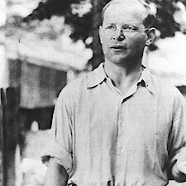

How did this come to be?
Dietrich Bonhoeffer’s life and the church which he had served were caught up in a massive fascist, authoritarian movement. As was the case in Benito Mussolini’s Italy, German fascism was “a far-right, authoritarian, ultranationalist political ideology and movement, characterized by a dictatorial leader, centralized autocracy, militarism, forcible suppression of any opposition, subordination of individual interests for the perceived good of the nation and/or race, and strong regimentation of society and the economy” (Wikipedia).
Yet neither fascism nor Hitler materialized overnight. The Nazi regime was fed by the debacle that had preceded it – Germany’s humiliating defeat in World War I. It flourished in a hot-house climate of economic collapse, nationalistic fervor, Christian impotence, and the desperate need to name a scapegoat to blame for Germany’s societal collapse – and by a “war within the war” against the Jewish people who were scapegoated for supposedly poisoning the blood of pure Aryan Germany and claiming a place on German soil despite being outsiders,.
The emerging horrors of Nazism relied most of all, however, on complacency; in the end only a fraction of Germany’s population were members of the National Socialist Party or actual perpetrators of the atrocities of genocide. Most Germans were simply bystanders; they watched what was occurring, and did nothing.

Even the Bonhoeffer family home in Berlin was only blocks away from the train station from which all the Jews of Berlin were sent to Auschwitz.
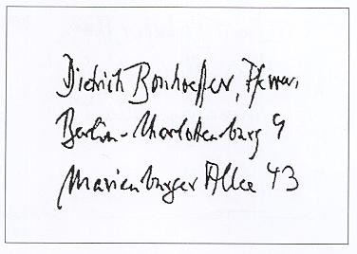
And yet they saw only as much as they would allow themselves to see. How did this come to be?
There was some organized resistance. Christian church people, mainly Protestants numbering around 5,000 pastors and lay people, formed the Confessing Church to try to stand up against Christian nationalism. In May, 1934; the Confessing Church labeled German Christian nationalism a heresy; but it was too little, and from the start too late. The so-called Deutsche Christen, who were loyal to Hitler, elected their own Bishop and began placing the Nazi flag their churches’ altars. Seeing no realistic possibility of a large-scale protest by the churches of Germany, the National Socialists passed the Nuremberg Laws in September 1935, taking away all protection of the law from the half-million Jews then living in Germany. The Confessing Church was to be, regrettably, Protestantism's finest hour during the 1930s, and its only even-marginally-successful concerted attempt to rouse the church to revolt against Nazism.
The Confessing Church seminary Bonhoeffer had organized in Finkenwalde was closed by the SS in 1937. In early 1939 Bonhoeffer was forbidden to preach or teach. His conscription papers arrived. He fled to London on July 2, 1939, and set out by boat for America. He immediately knew he was wrong. Spurred on by a colleague who wrote him saying “your Church is on fire, come home” – On July 7, 1939 he did. On September 1, 1939, Germany invaded Poland to start WWII.
Jews were required to start wearing the Yellow Star in the fall of 1941. Concentration Camps, the first of which opened all the way back in 1933, became death camps, as the first gas chambers at Auschwitz were installed. On January 20, 1942, Nazi leaders met to arrive at a solution to what was labeled “the Jewish problem.” They departed with the Final Solution, plans for the genocidal extermination of all Jews, starting in Europe. When they were done, 6 ½ million Jewish people, including 1 ½ million children had been slaughtered.

